End keyboard settings to go to end of word instead of clearing

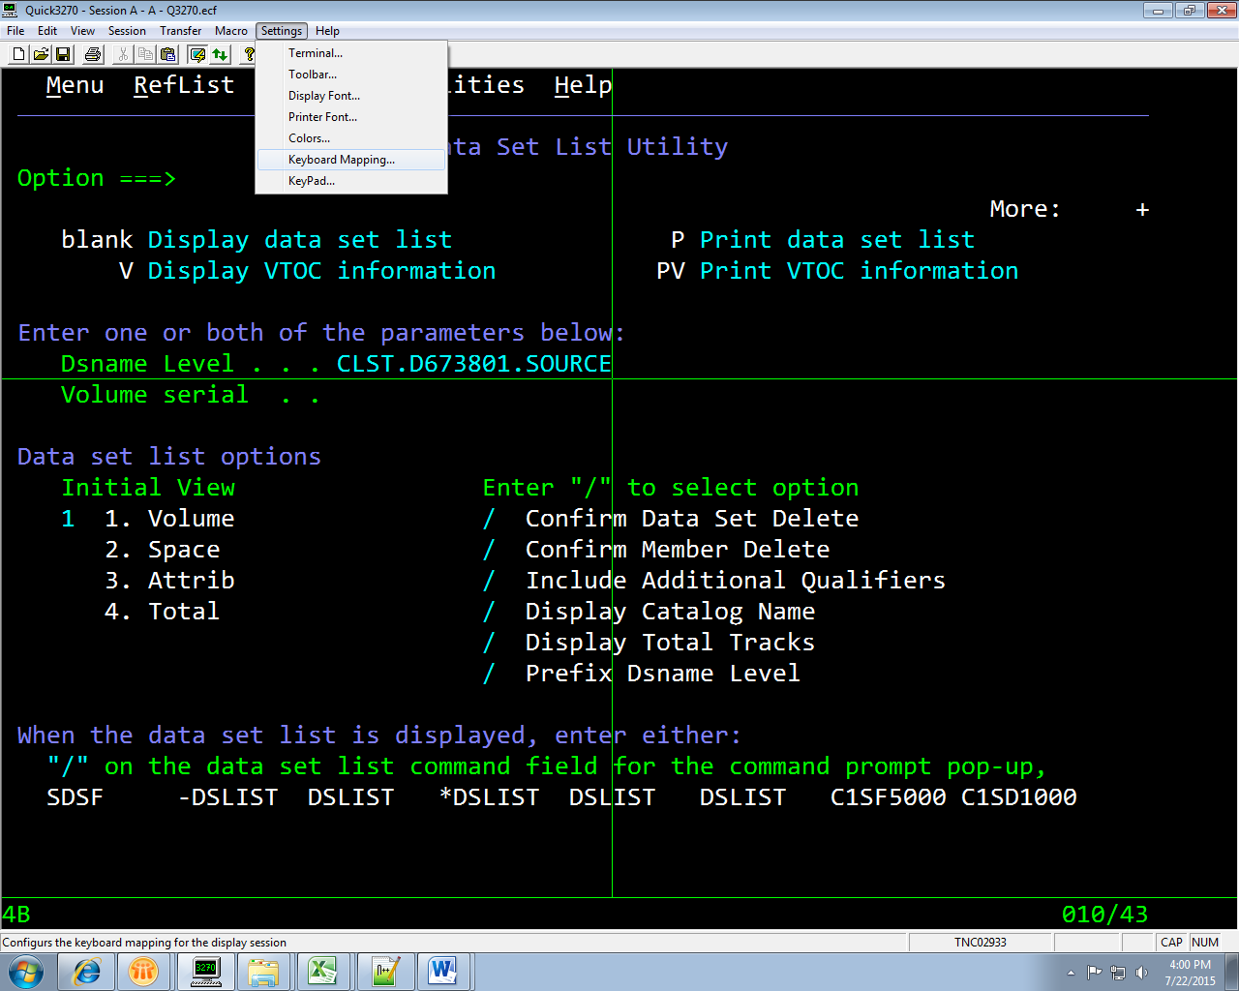

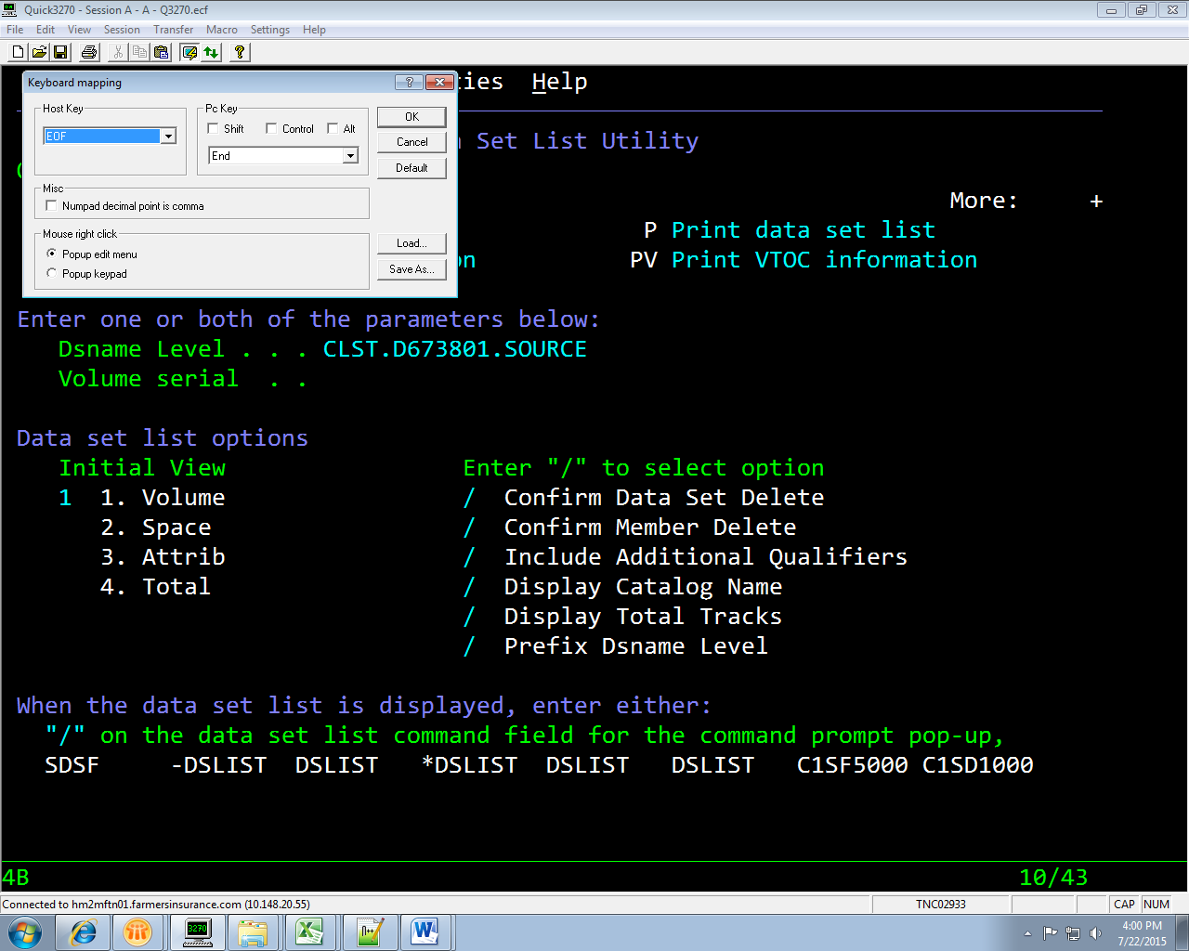

Destructive Back space
Activate backspace for deleting

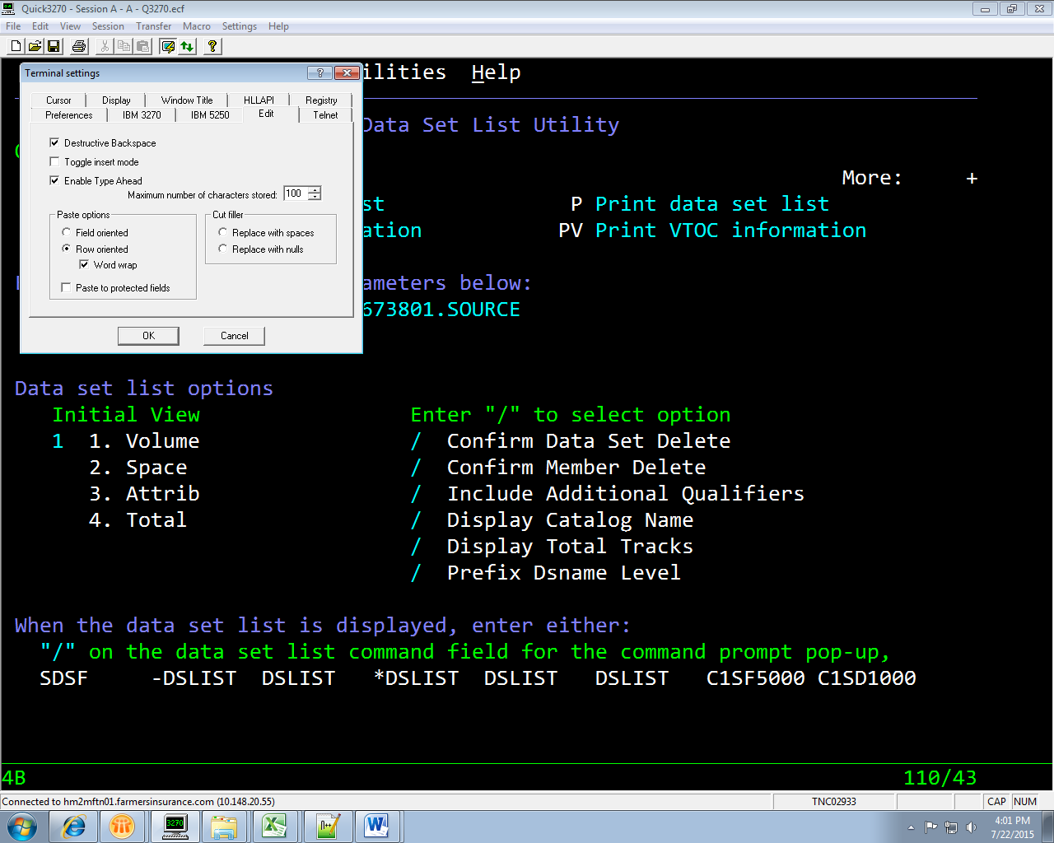

Delete all data

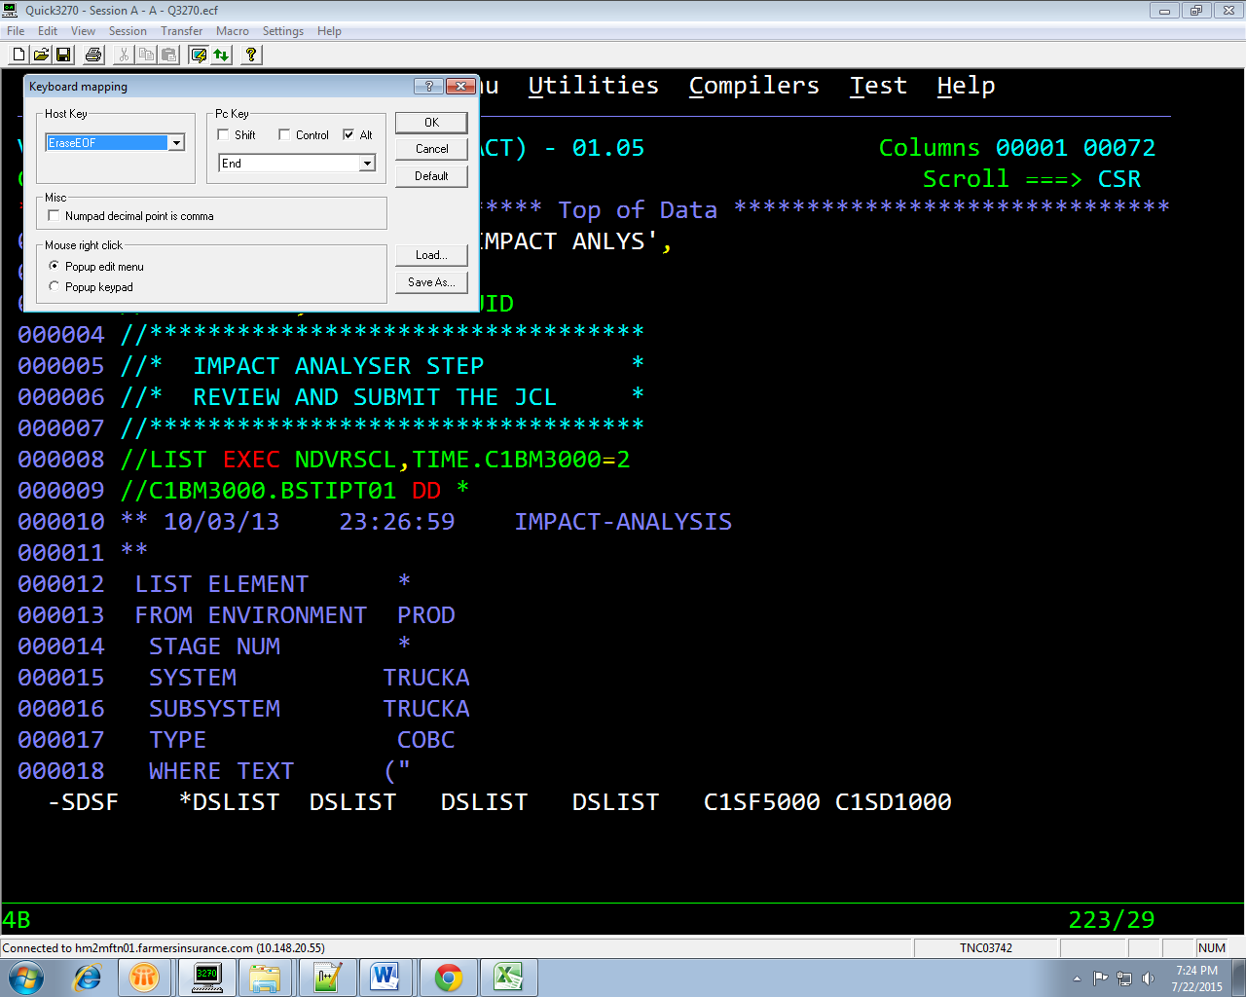

Endeavour
View Elements in Endevour
EE;;1;;1

The system and subsystem can be either TRUCKA OR TRUCKB

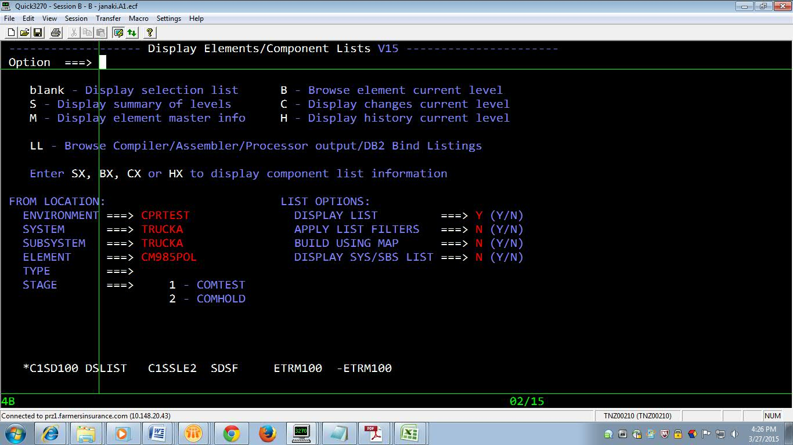

SCL generation process

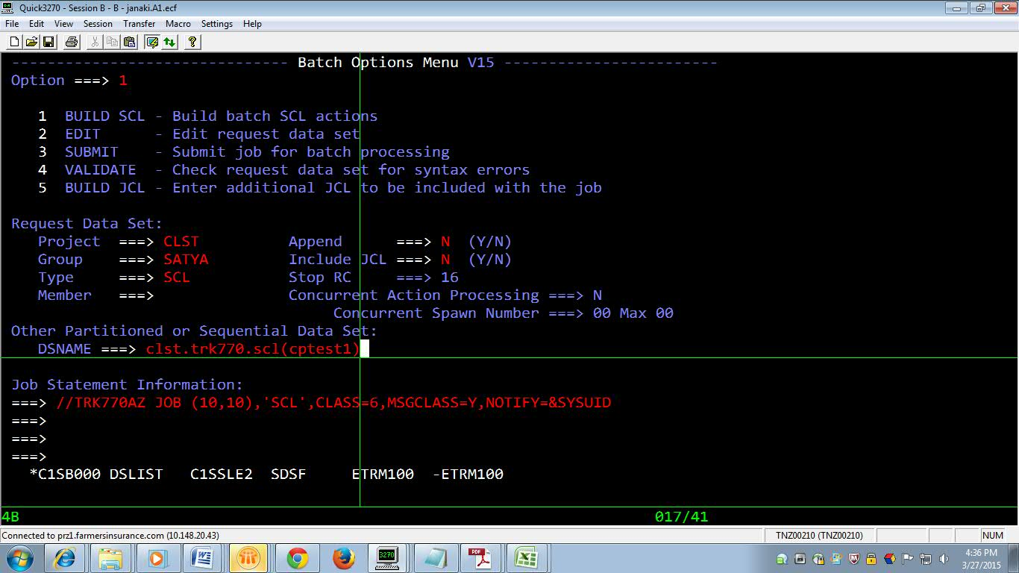
//TRK770AZ JOB (10,10),’SCL’,CLASS=6,MSGCLASS=Y,NOTIFY=&SYSUID

To add a Endevour element by creating SCL
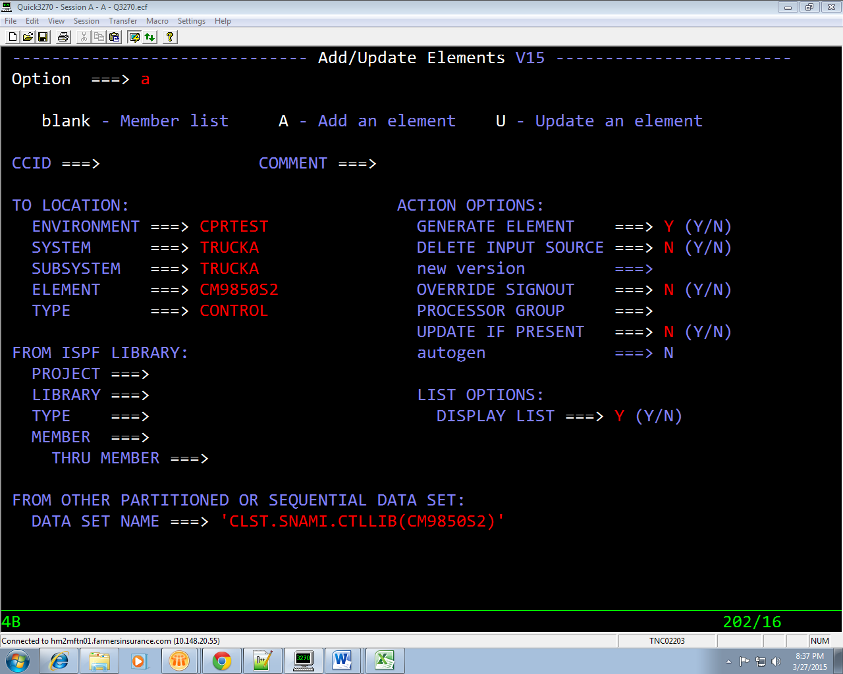
FAST TRACK Project Specific
- The order of environments in which we have to look for the member to be checked out from Endevour is
- CPRTEST1
- CPRTEST2
- PROD

- After the changes are made to the code the data will be moved to CPRTEST1 environment then we only push it to CPRTEST2.

Mainframe Font adjustment

Logging into Mainframe

- Open the emulator Quick3270
- One time settings
Server name : hm2mftn01.farmersinsurance.com

- Enter F – to see all regions CICS and TSO
- Enter uname/pwd
- List of test regions
TSOJ1
TSOA1
TSOB1
List of CICS Test regions
CICSTS41
CICSTN41
- List of Production regions
TSOX1
List of CICS Prod regions
CICSOS41
CICSOA41
CICSOI41

Mainframe Shortcuts

- SHIFT + F1 for switching between TSO and CICS
- START TSO EE;; A go to Endevour
- Mirror for copying a dataset.
- JC append job card to job.
- Login to a session give COMMAND : TSOJ1.
To login to CICS give COMMAND: TSO APPLID(CICSLD11)
To show all sessions give COMMAND: F

- Press pausebreak for entering new command.
- swapbar on – to show screens
- Fileaid shortcuts
EQ for equals
=
CO for Contains.

List of Key Transactions

- UCD0

File aid

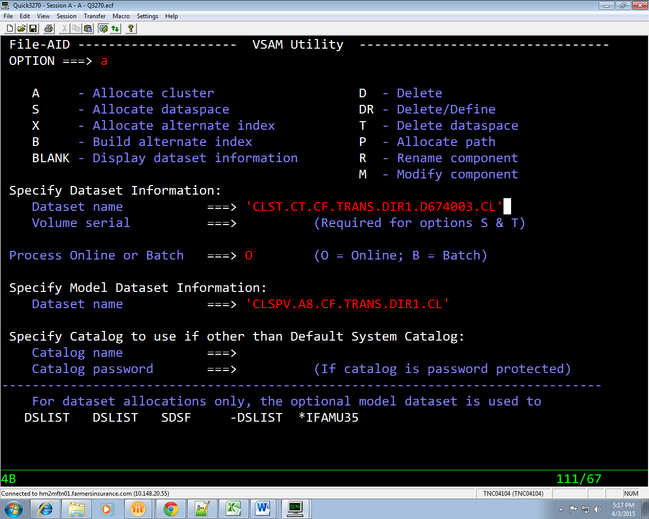

File Compare 3.13

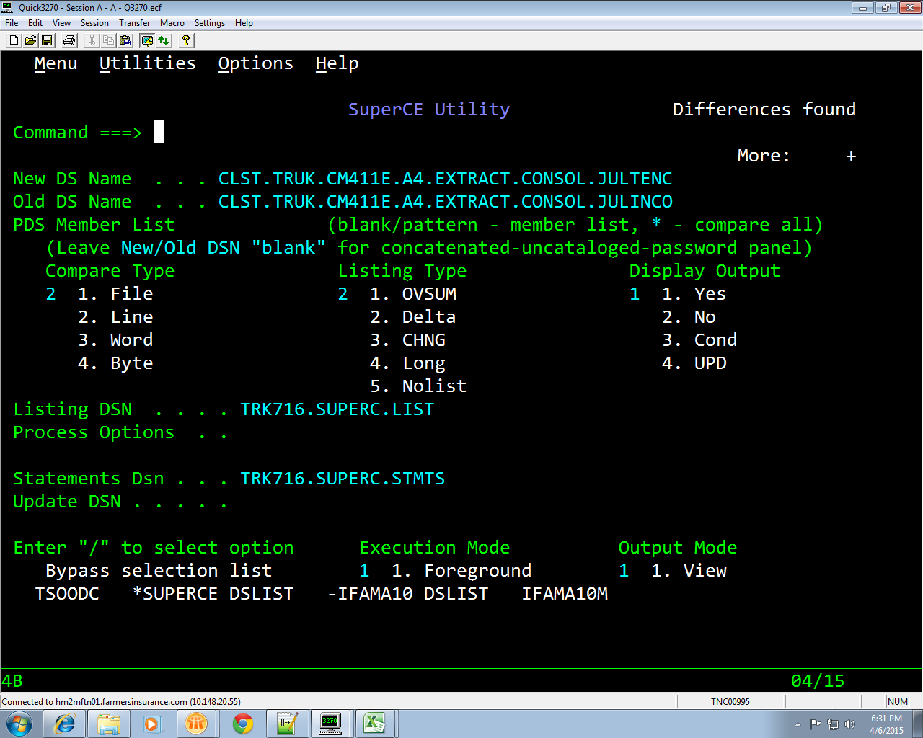

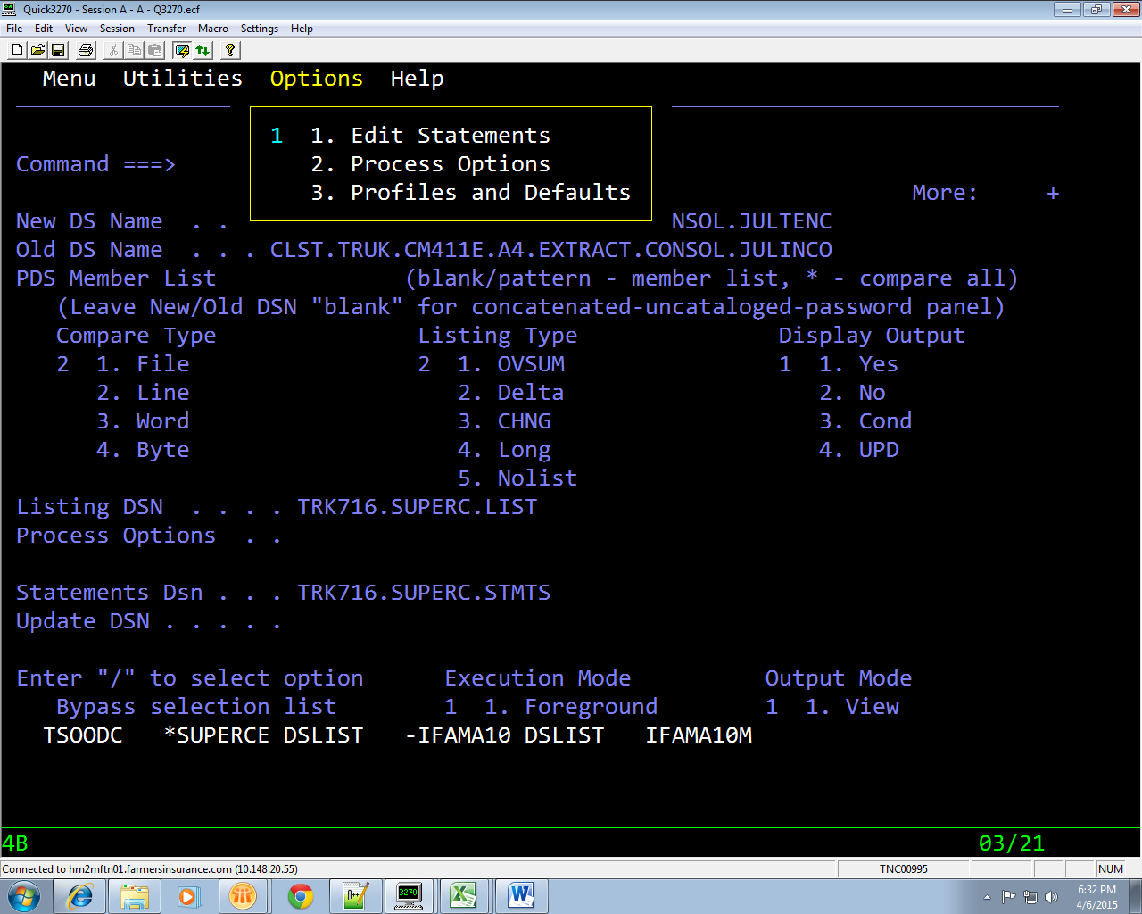

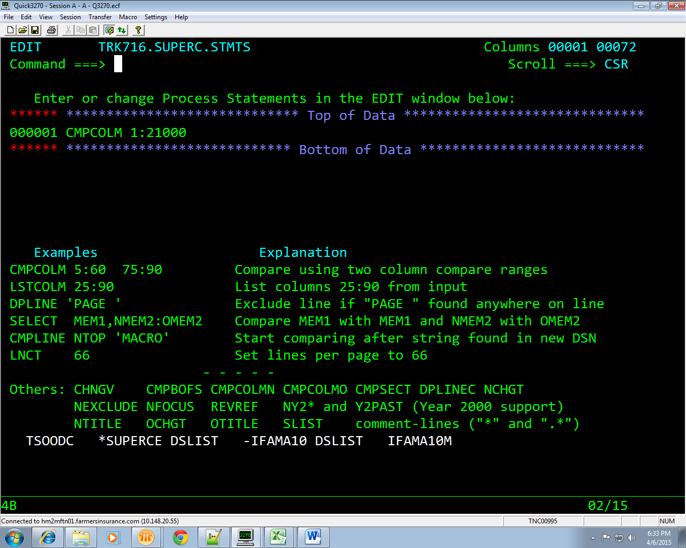

Raise NSR Request from Chat on

http://chat.csc.com/

Project Name: Zurich Farmers
You work in ASIAPAC/Other Domain: ASIAPAC
Unit / Floor/Building :Hyderabad/Mindspace/B4/5F
Seat / Cubicle/cabin :560
Alternate Contact number :9052298330
Available Time:9 to 6

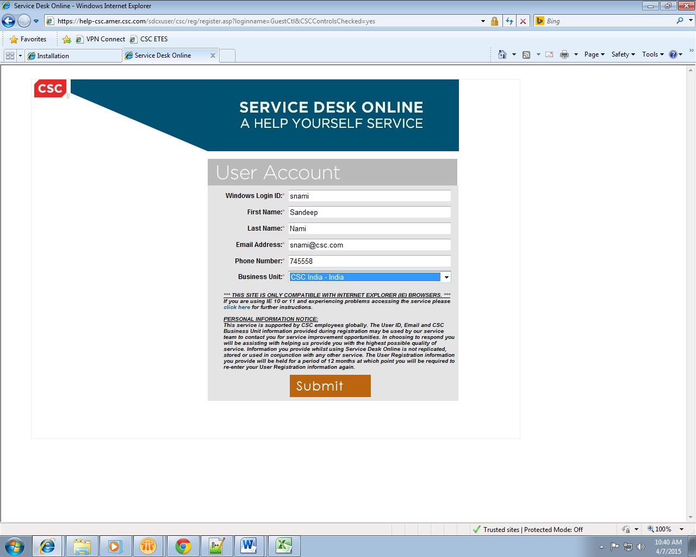

Proxy settings for VPN Login

Proxy: http://proxyhyd.asia.csc.com/proxy.pac
Address : 20.198.64.13
Port: 6588
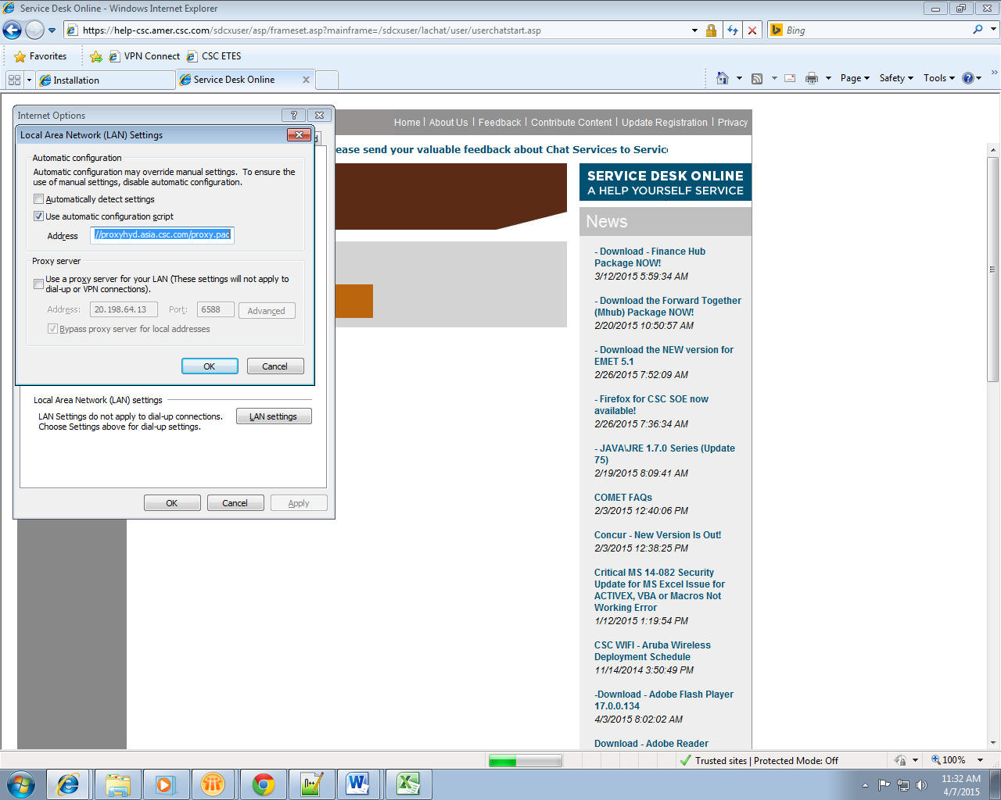

Proxy settings for accessing all sites

Address: 20.198.64.13
Bypass proxy:
http://proxynoi.asia.csc.com/proxy.pac
Address :
Port: 80

